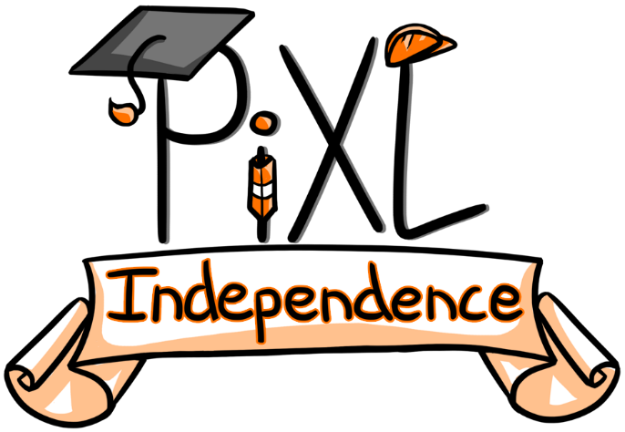

PiXL Independence
SLAT English Literature – Student Booklet
KS4

All Boards Style Romeo and Juliet
Contents:
Answers

Answers
- Context Quiz
- When was ‘Romeo and Juliet’ written? 1595
- From what age were girls allowed to marry? 12 years old. Juliet was 13 in the play.
- Where was the play set? Verona, Italy
- Who first brought the idea of ‘Romeo and Juliet’ into the English-speaking world? A poet, Arthur Brooks
- Which other poem may have influenced Shakespeare during his writing of ‘Romeo and Juliet’? Ovid’s Pyramus and Thisbe
- How were women treated in the Elizabethan era? Why is this relevant to the play? Society was patriarchal so women were seen as subordinate to men. This is particularly clear in the relationship between Lord Capulet and Juliet, as she had to obey him.
- How were marriages arranged? Children were not free to marry whom they wanted; their parents chose for them.
- Who were upper class children often raised by? They were raised by wet nurses who breast-fed and weaned and cared for them.
- How does Shakespeare subvert the religious fervour of the time period? Shakespeare made use of a lot of religious imagery between Romeo and Juliet to show they worship one another and are devoted to each other, and sometimes this touched on blasphemy.
- In which historical event did England break from the Catholic faith in Rome? The Reformation.

- Context Quiz
Quiz One –  Act 1 | Quiz Two –  Act 2 | Quiz Three – Act 3
B | C | B
C | A | D
D | D | C
A | C | B
A | A | A
C | B | B
C | C | D
C | D | C
D | B | C
A | A | D

Quiz Four –  Act 4 | Quiz Five –  Act 5 | Quiz Six –  Who said that? | Quiz Seven –  Who am I? | Quiz Eight –  Themes and symbols
C | D | A | A | A
D | B | C | D | B
B | C | A | B | B
B | C | D | A | C
C | A | B | C | D
A | D | B | D | C
D | D | A | B | A
D | B | D | A | C
C | C | C | A | A
A | D | D | B | B

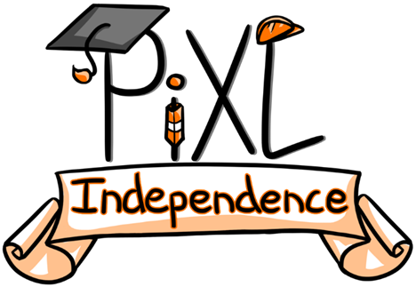

Commissioned by The PiXL Club Ltd.

This resource is strictly for the use of member schools for as long as they remain members of The PiXL Club. It may not be copied, sold, or transferred to a third party or used by the school after membership ceases. Until such time it may be freely used within the member school.

All opinions and contributions are those of the authors. The contents of this resource are not connected with, or endorsed by, any other company, organisation or institution.

PiXL Club Ltd endeavour to trace and contact copyright owners. If there are any inadvertent omissions or errors in the acknowledgements or usage, this is unintended and PiXL will remedy these on written notification.

