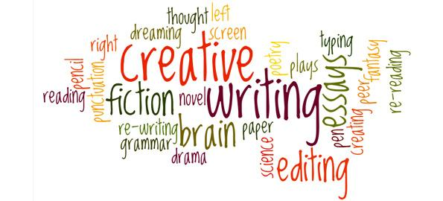

Language Question Paper 1

Paper 1 Section A:
Question 1: List four things (4 marks)
Question 2: Identify language (8 marks)
Question 3: Identify structural features (8 marks)
Question 4: How far do you agree...?you will be given a statement (20 marks)
Section B:
Creative Writing (Write a description suggested by a picture/Write the opening to a story) (40 marks)
Timings:
Question 1 – 5 minutes
Question 2 – 10 minutes
Question 3 – 10/15 minutes
Question 4 – 20-25 minutes
Question 5 – 5 minutes planning
35 minutes writing
5 minutes checking

Source A
This extract is from a novel by Margaret Atwood, first published at the beginning of the 21st Century. In this section, a character closely examines a photograph that was taken many years before.
The Blind Assassin
1.She has a single photograph of him. She tucked it into a brown envelope on which she'd written clippings, and hid the envelope between the pages of Perennials for the Rock Garden, where no one else would ever look.
4.She's preserved this photo carefully, because it's almost all she has left of him. It's black and white, taken by one of those boxy, cumbersome flash cameras from before the war, with their accordion-pleat nozzles and their well-made leather cases that looked like muzzles, with straps and intricate buckles. The photo is of the two of them together, her and this man, on a picnic. Picnic is written on the back, in pencil - not his name or hers, just picnic. She knows the names, she doesn't need to write them down.
10.They're sitting under a tree; it might have been an apple tree; she didn't notice the tree much at the time. She's wearing a white blouse with the sleeves rolled to the elbow and a wide skirt tucked around her knees. There must have been a breeze, because of the way the shirt is blowing up against her; or perhaps it wasn't blowing, perhaps it was clinging; perhaps it was hot. It was hot. Holding her hand over the picture, she can still feel the heat coming up from it, like the heat from a sun-warmed stone at midnight.
16.The man is wearing a light-coloured hat, angled down on his head and partially shading his face. His face appears to be more darkly tanned than hers. She's turned half towards him, and smiling, in a way she can't remember smiling at anyone since. She seems very young in the picture, too young, though she hadn't considered herself too young at the time. He's smiling too - the whiteness of his teeth shows up like a scratched match flaring – but he’s holding up his hand, as if to fend her off in play, or else to protect himself from the camera, from the person who must be there, taking the picture; or else to protect himself from those in the future who might be looking at him, who might be looking at him through this square, lighted window of glazed paper. As if to protect himself from her. As if to protect her. In his outstretched, protecting hand there’s the stub end of a cigarette.
25.She retrieves the brown envelope when she’s alone, and slides the photo out from among the newspaper clippings. She lies it flat on the table and stares down into it, as if she’s peering into a well or pool – searching beyond her own reflection for something else, something she must have dropped or lost, out of reach but still visible, shimmering like a jewel on sand. She examines every detail. His fingers bleached by the flash or the sun’s glare; the folds of their clothing; the leaves of the tree, and the small round shapes hanging there – were they apples, after all? The coarse grass in the foreground. The grass was yellow then because the weather had been dry.
32.Over to one side – you wouldn’t see it at first – there’s a hand, cut by the margin, scissored off at the wrist, resting on the grass as if discarded. Left to its own devices.
The trace of brown cloud in the brilliant sky, like ice cream smudged on chrome. His smoke-stained fingers. The distant glint of water. All drowned now.
Drowned, but shining.

Question 1: Read again this part of the source, lines 1 to 9.
List four things from this part of the text about the photograph.
[4 marks]

1__________________________________________________________________________

2._________________________________________________________________________

3.________________________________________________________________________

4._________________________________________________________________________

Question 2: Look in detail at this extract from lines 16 to 24 of the source.

The man is wearing a light-coloured hat, angled down on his head and partially shading his face. His face appears to be more darkly tanned than hers. She's turned half towards him, and smiling, in a way she can't remember smiling at anyone since. She seems very young in the picture, too young, though she hadn't considered herself too young at the time. He's smiling too - the whiteness of his teeth shows up like a scratched match flaring – but he’s holding up his hand, as if to fend her off in play, or else to protect himself from the camera, from the person who must be there, taking the picture; or else to protect himself from those in the future who might be looking at him, who might be looking at him through this square, lighted window of glazed paper. As if to protect himself from her. As if to protect her. In his outstretched, protecting hand there’s the stub end of a cigarette.

How does the writer use language here to describe the photograph?
You could include the writer’s choice of:
- Words and phrases
- Language features and techniques
- Sentence forms
[8 marks]

Question 3: You now need to think about the whole of the source.
This text is from the early part of a novel.
How has the writer structured the text to interest you as a reader?
You could write about:
- What the writer focuses your attention on at the beginning
- How and why the writer changes this focus as the source develops
- Any other structural features that interest you
[8 marks]

Question 4: Focus on lines 25 to the end.
‘The writer successfully creates an air of mystery around the photograph’.

To what extent do you agree with this statement?
- Examine how the writer creates an air of mystery around the photograph
- Evaluate the extent to which the writer is successful in doing this
- Support your opinions and judgements with quotations from the text
[20 marks]

Q5: Section B: Writing
You are advised to spend about 45 minutes on this section. Write in full sentences. You are reminded of the need to plan your answer. You should leave enough time to check your work at the end.
You are going to enter a creative writing competition.
Your entry will be judged by a panel of professional writers.
Either:
Write a story in which a photograph plays a significant part.
OR:
Write a description suggested by this photograph:
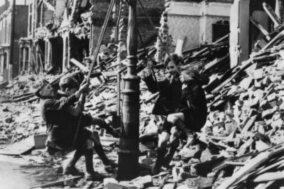

(24 marks for content and organisation
16 marks for technical accuracy)

