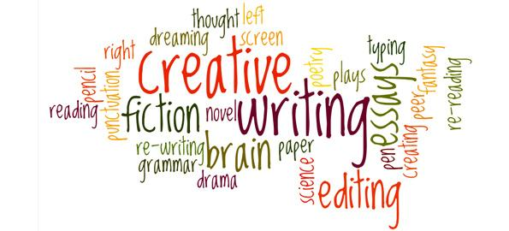

Language
Question Paper 1
CHECKLIST AND EXAMPLE MATERIAL

Source A
This extract is from a novel by Margaret Atwood, first published at the beginning of the 21st Century. In this section, a character closely examines a photograph that was taken many years before.
The Blind Assassin
1.She has a single photograph of him. She tucked it into a brown envelope on which she'd written clippings, and hid the envelope between the pages of Perennials for the Rock Garden, where no one else would ever look.
4.She's preserved this photo carefully, because it's almost all she has left of him. It's black and white, taken by one of those boxy, cumbersome flash cameras from before the war, with their accordion-pleat nozzles and their well-made leather cases that looked like muzzles, with straps and intricate buckles. The photo is of the two of them together, her and this man, on a picnic. Picnic is written on the back, in pencil - not his name or hers, just picnic. She knows the names, she doesn't need to write them down.
10.They're sitting under a tree; it might have been an apple tree; she didn't notice the tree much at the time. She's wearing a white blouse with the sleeves rolled to the elbow and a wide skirt tucked around her knees. There must have been a breeze, because of the way the shirt is blowing up against her; or perhaps it wasn't blowing, perhaps it was clinging; perhaps it was hot. It was hot. Holding her hand over the picture, she can still feel the heat coming up from it, like the heat from a sun-warmed stone at midnight.
16.The man is wearing a light-coloured hat, angled down on his head and partially shading his face. His face appears to be more darkly tanned than hers. She's turned half towards him, and smiling, in a way she can't remember smiling at anyone since. She seems very young in the picture, too young, though she hadn't considered herself too young at the time. He's smiling too - the whiteness of his teeth shows up like a scratched match flaring – but he’s holding up his hand, as if to fend her off in play, or else to protect himself from the camera, from the person who must be there, taking the picture; or else to protect himself from those in the future who might be looking at him, who might be looking at him through this square, lighted window of glazed paper. As if to protect himself from her. As if to protect her. In his outstretched, protecting hand there’s the stub end of a cigarette.
25.She retrieves the brown envelope when she’s alone, and slides the photo out from among the newspaper clippings. She lies it flat on the table and stares down into it, as if she’s peering into a well or pool – searching beyond her own reflection for something else, something she must have dropped or lost, out of reach but still visible, shimmering like a jewel on sand. She examines every detail. His fingers bleached by the flash or the sun’s glare; the folds of their clothing; the leaves of the tree, and the small round shapes hanging there – were they apples, after all? The coarse grass in the foreground. The grass was yellow then because the weather had been dry.
32.Over to one side – you wouldn’t see it at first – there’s a hand, cut by the margin, scissored off at the wrist, resting on the grass as if discarded. Left to its own devices.
The trace of brown cloud in the brilliant sky, like ice cream smudged on chrome. His smoke-stained fingers. The distant glint of water. All drowned now.
Drowned, but shining.

Q1 LIST FOUR THINGS
CHECK!
It is a relatively straightforward question. It is asking you to identify four distinct things about the photograph.
Check your answers against the following list and decide how many you identified correctly:
- It is the only one she has of him
- It was hidden in an envelope between the pages of Perennials for the Rock Garden, where no one else would ever look.
- It had been carefully preserved.
- It was black and white.
- It was taken by one of those boxy, cumbersome flash cameras.
- It was taken from before the war.
- It was of the two of them together on a picnic.
- Picnic is written on the back, in pencil.

Q2 LANGUAGE
CHECK!
This question tests your skill in examining and commenting on the writer’s use of language – her phrases, language features, language techniques and sentence forms (AO2)
You should:
- Show you understand the writer’s use of language
- Examine and analyse the effects of the writer’s language choices
- Select and use relevant quotations
- Use appropriate subject terminology to discuss language use. You might, for example, comment on the writer’s use of adjectives or similes.

SAMPLE RESPONSE!
The writer uses a range of techniques to describe the photograph. She uses the simile ‘like a scratched match flaring’ to describe the man’s smile. The verb ‘flaring’ makes it seem sudden and has connotations of danger. She repeats the adjective ‘young’ three times in one sentence to describe the woman and emphasises this even more by saying twice that she is ‘too’ young. This makes it seem as though she shouldn’t have been there with this man because she wasn’t old enough. She also uses repetition later in the paragraph when she repeats the word ‘protect’ in the sentences: ‘As if to protect himself from her. As if to protect her’ These two sentences are structures in very similar ways but they have a different meaning and the short words ‘as if’ at the start of each sentence make the reader realise that she doesn’t know why the man was holding up his hand and it maybe shows that she wasn’t very sure about him.
The writer also uses an effective metaphor near the end. She calls the photograph a ‘a square lighted window’. The transparency of the metaphor gives a sense to the reader of looking through a window into the world of this man and woman.
Question 3: You now need to think about the whole of the source.
This text is from the early part of a novel.
How has the writer structured the text to interest you as a reader?
You could write about:
- What the writer focuses your attention on at the beginning
- How and why the writer changes this focus as the source develops
- Any other structural features that interest you
[8 marks]

Q3 – STRUCTURE
CHECK!
You should:
- Show you understand features of structure
- Examine and analyse the effects of the writer’s choice of structural features
- Select and use relevant examples
- Use appropriate subject terminology to discuss structure
Structural features can be:
- At a whole text level – for example beginnings, endings and shifts in focus
- At a paragraph level – for example topic changes, single-sentence paragraphs
- At a sentence level – for example sentence lengths
- Write at least 3 paragraphs

SAMPLE RESPONSE
The writer begins with a simple sentence ‘She has a single photograph of him’. This opening establishes a sense of the photograph being of significance. The importance of the photograph is reinforced when she hides it away later on in the opening paragraph ‘where no one else would ever look’. This creates mystery and whets the reader’s appetite as they are intrigued to find out more. The third paragraph zooms into actual details of the photograph ‘the tree…white blouse…wide skirt’. This creates a flashback to an earlier point in the narrator’s life and suggests to the reader that she is delving into her past. It seems to be a happy time in her life because she seems not to notice much around her aside from the photograph being taken. Furthermore, the ‘heat’ coming up from the photograph perhaps suggests warm and happier times. The use of questions and shifting from the past to the present is suggestive of the present narrator searching deep into her past and trying to piece together key events. There is a sense of nostalgia as she questions things ‘were they apples?’. There is a darker tone towards the end of the extract with the description of a hand ‘scissored off at the wrist’ suggesting that in hindsight the speaker sees things in a different light. This is ominous and leaves the reader wondering what has happened. The very last sentence is on its own “Drowned, but shining” suggesting something ominous had occurred after.

Question 4: Evaluation question
CHECK!
You should:
- Clearly evaluate the text
- Offer examples from the text to explain your views
- Explain the effect of writer’s choices
- Select relevant quotations to support your views
- Write 5-6 paragraphs.

SAMPLE RESPONSE:
The writer creates an air of mystery around the photograph from the start when she ‘slides the photograph out from among the newspaper clippings’. The use of the verb ‘slide’ shows how it has been hidden away and she has to look at it secretly. She stares at it as if ‘searching for something else’ which makes it sound mysterious and intriguing to the reader. She then says how looking at it is like looking into a ‘well or pool’. The use of simile suggests she is delving into the past in search of something. This suggests that the photograph as well as being a secret in itself, also holds further secrets that can’t be seen on first examination. The woman then examines the photograph in ‘every detail’ and notices things that haven’t been mentioned before like the ‘folds of their clothing’. As the narrator scrutinises the picture so closely, the reader expects her to find something and solve the mystery of the photograph but she never does. The mention of a hand that is ‘scissored’ off sounds ominous and unsettling. The sharp verb ‘scissored’ sounds bizarre and out of place in the context of the photograph as though somebody has deliberately cut it. This is strange and creates a sense of mystery and enigma for the reader.

Q5 - Section B: Writing
Either:
Write a story in which a photograph plays a significant part.
OR:
Write a description suggested by this photograph:
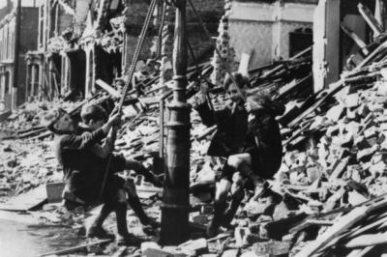

CHECK!
- Use language techniques such as similes and metaphors
- Use lots of punctuation
- Use a range of sentence structures
- Use interesting vocabulary
- Open your sentences in different ways e.g. words ending in –ly or –ed
- Vary your paragraph lengths

Sample opening for first question:
The photograph took pride of place on the mantelpiece. I had often caressed the glossy paper with a feather duster – often to infuriate him. I gingerly fingered the edges of the curling paper; I had meant to get it framed. I sighed. Staring solidly at it for longer than a few seconds brought fragments of old memories flooding back like some shadow of a person greeting their long lost lover.
The first memory began to materialise before my eyes…
I remembered how it had been a cold, rainy night. The rain had pattered dismally against the window forming tears that poured down like the tears of one who is deeply grieving. Was it then? No, it was some time later when I had been lost in a muddle of thoughts that I heard it. A soft knocking. Almost inaudible. I had definitely heard it though and wondered momentarily whether it had been the distant rumble of thunder. Then it came again. This time louder. Persistent. I had gone to open it and a stream of sunlight had flooded the room…
Sample opening for second question:
I am invisible to them. Yet I watch them nearly every day. There are usually hordes of them, but today this number has been diminished significantly to only four. I watch. Staring transfixed, I wonder how they retain such exuberance. They are dishevelled and ragged; some are clearly malnourished. The debris and filthy rubble is their playground. The air is silent aside from their laughter. It is not always like this…
Occasionally, a sudden blast. And then a horrifying scream piercing the air. Today, I take consolation in their carefree laughter…

PRACTISE!
Source A
This extract is from the beginning of a novel by Ian McEwan, it was first published in 1997.
In this section, the narrator, Gadd and other men are trying to stop a hot air balloon from flying off. Inside the basket is a terrified boy.

Enduring Love

1.A mighty fist of wind socked the balloon in two rapid blows, one-two, the second more vicious than the first. It jerked Gadd right out of the basket on to the ground, and with Gadd's considerable weight removed from the equation, it lifted the balloon five feet or so, straight into the air. The rope ran through my grip, scorching my palms, but I managed to keep hold, with two feet of line spare. The others kept hold too. The basket was right above our heads now, and we stood with arms upraised like Sunday bell ringers. Into our amazed silence, before the shouting could resume, the second punch came and knocked the balloon up and westwards. Suddenly we were treading the air with all our weight in the grip of our fists.
Those one or two ungrounded seconds occupy as much space in memory as might a long journey up an unchartered river. My first impulse was to hang on in order to keep the balloon weighted down. The child was incapable, and was about to be borne away. Two miles to the left were high-voltage power lines. A child alone and needing help. It was my duty to hang on, 13.and I thought we would all do the same.

Almost simultaneous with the desire to stay on the rope and save the boy came other thoughts of self-preservation and fear. We were rising, and the ground was dropping away as the balloon was pushed westwards. I knew I had to get my legs and feet locked round the rope. But the end of the line barely reached below my waist and my grip was slipping. My legs flailed in the empty air. Every fraction of a second that passed increased the drop, and the point must come when to let go would be impossible or fatal. Then, someone did let go. Immediately, the 20.balloon and its hangers on lurched upwards another several feet.

Because letting go was in our nature too. Selfishness is also written on our hearts. Mostly, we are good when it makes sense. A good society is one that makes sense of being good. Suddenly, hanging there below the basket, we were a bad society, we were disintegrating. Suddenly the sensible choice was to look out for yourself. The child was not my child, and I was not going to die for it. Then I glimpsed another body fall away and I felt the balloon lurch upwards. The matter was settled. Altruism had no place. Being good made no sense. I let go and fell, I reckon, about twelve feet. I landed heavily on my side, I got away with a bruised thigh. Around me – 28.before or after, I'm not so sure - bodies were thumping to the ground.

By the time I got to my feet the balloon was fifty yards away, and one man was still dangling by his rope. When I stood up and saw him, he was one hundred feet, and rising, just where the ground itself was falling. He wasn’t struggling, he wasn’t kicking or trying to claw his way up. He hung perfectly still along the line of his rope, all his energies concentrated in his weakening grip. He was already a tiny figure almost black against the sky and as the balloon and its basket 34.lifted away and westwards, the smaller he became and the more terrible it was.

40.Our silence was a kind of acceptance, a death warrant. Or it was horrified shame. He had been on the rope so long that I began to think he might stay there until the balloon drifted down. But even as I had that hope we saw him slip down right to the end of the rope. And still he hung there. For two seconds, three, four. And then he let go and ruthless gravity played its part. And from somewhere a thin squawk cut through the stilled air. He fell as he had hung, a stiff little black stick. I've never seen such a terrible thing as that falling man.

Question 1. Read again the first part of the source, lines 1 – 8.
List four details from this part of the text about the wind:
[4 Marks]
A.________________________________________________________________________________
B.________________________________________________________________________________
C.________________________________________________________________________________
D.________________________________________________________________________________

Question 2: Look in detail at this extract from lines 9 - 20 of the source:
Those one or two ungrounded seconds occupy as much space in memory as might a long journey up an unchartered river. My first impulse was to hang on in order to keep the balloon weighted down. The child was incapable, and was about to be borne away. Two miles to the left were high-voltage power lines. A child alone and needing help. It was my duty to hang on, and I thought we would all do the same.

Almost simultaneous with the desire to stay on the rope and save the boy came other thoughts of self-preservation and fear. We were rising, and the ground was dropping away as the balloon was pushed westwards. I knew I had to get my legs and feet locked round the rope. But the end of the line barely reached below my waist and my grip was slipping. My legs flailed in the empty air. Every fraction of a second that passed increased the drop, and the point must come when to let go would be impossible or fatal. Then, someone did let go. Immediately, the balloon and its hangers on lurched upwards another several feet.

How does the writer use language here to describe the thoughts of the narrator?
You could include the writer’s choice of:
- words and phrases
- language features and techniques
- sentence forms.
[8 marks]
__________________________________________________________________________________________________________________________________________________________________________________________________________________________________________________________________________________________________________________________________________________________________________________________________________________________________________________________________________________________________________________________________________________________________________________________________________________________________________________________________________________________________________________________________________________________________________________________________________________________________________________________________________________________________________________________________________________________________________________________________________________________________________________________________________________________
3. You now need to think about the whole of the source.
This text is from the beginning of a novel.
How has the writer structured the text to interest you as a reader?
You could write about:
- what the writer does to create an atmosphere at the beginning
- how and why the writer changes the focus as the extract develops
- any other structural features that interest you.
[8 marks]
___________________________________________________________________________________________________________________________________________________________________________________________________________________________________________________________________________________________________________________________________________________________________________________________________________________________________________________________________________________________________________________________________________________________________________________________________________________________________________________________________________________________________________________________________________________________________________________________________________________________________________________________________________________________________________________________________________________________________________________________________________________________________________________________________________________________________________________________________________________________________________________________________________________________________________________________________________________________________________________________________________________________________________________________________________________________________________________________________________________________________________________________________________________________________________________________________________________________________________________________________________________________________________________________________________________________________________________________________________________________________________________________________________________________________________________________________________________________________________________________________________________________________________________________________________________________________________________________________________________________________________________________________________________________________________________________________________________________________________________________________________________________________________________________________________________________________________________________________________________________________________________________________________________________________________
4. Focus this part of your answer on the second half of the source, from line 21 to the end.
A student, having read this section of the text said: “The writer vividly conveys the horror of the situation. It is as if you are there with the narrator.”
To what extent do you agree?
In your response, you should:
- write about your own impressions of what the narrator witnesses
- evaluate how the writer has created these impressions
- support your opinions with quotations from the text.
[20 marks]
________________________________________________________________________________________________________________________________________________________________________________________________________________________________________________________________________________________________________________________________________________________________________________________________________________________________________________________________________________________________________________________________________________________________________________________________________________________________________________________________________________________________________________________________________________________________________________________________________________________________________________________________________________________________________________________________________________________________________________________________________________________________________________________________________________________________________________________________________________________________________________________________________________________________________________________________________________________________________________________________________________________________________________________________________________________________________________________________________________________________________________________________________________________________________________________________________________________________________________________________________________________________________________________________________________________________________________________________________________________________________________________________________________________________________________________________________________________________________________________________________________________________________________________________________________________________________________________________________________________________________________________________________________________________________________________________________________________________________________________________________________________________________________________________________________________________________________________________________________________________
Section B: Writing
You are advised to spend about 45 minutes on this section. Write in full sentences. You are reminded of the need to plan your answer. You should leave enough time to check your work at the end.
Question 5: You are going to enter a creative writing competition.
Your entry will be judged by a panel of professional writers.
Either:
Write a story in which a hot air balloon plays a significant part.
OR:
Write a description suggested by this photograph:
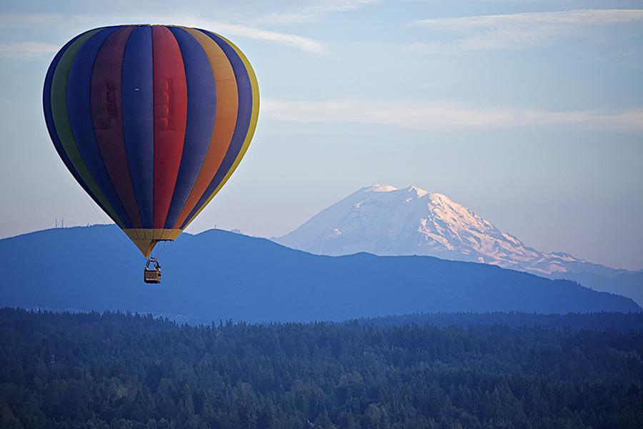

(24 marks for content and organisation
16 marks for technical accuracy)

