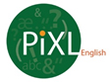

SLAT English Literature – Answer Booklet
KS4

All Boards Style, A Christmas Carol

Contents:
Answers

- Multiple Choice Quizzes

Quiz One –  Context | Quiz Two –  Who said that? | Quiz Three –  Who am I? | Quiz Four –  Stave 1 | Quiz Five – Stave 2
B | C | D | C | B
C | A | C | B | B
C | C | B | D | A
A | B | A | C | C
B | D | C | A | B
C | A | A | C | A
A | D | A | A | C
D | C | B | C | B
B | A | C | C | C
A | D | C | A | A

Quiz Six –  Stave 3 | Quiz Seven –  Stave 4 | Quiz Eight-  Stave 5 | Quiz Nine –  Who said that? | Quiz Ten –  Themes and symbols
A | B | C | A | A
C | A | B | D | C
D | A | C | B | C
A | C | A | D | A
D | A | D | A | B
D | D | B | C | D
C | B | C | D | C
D | A | C | A | B
D | C | D | C | B
C | B | C | A | C

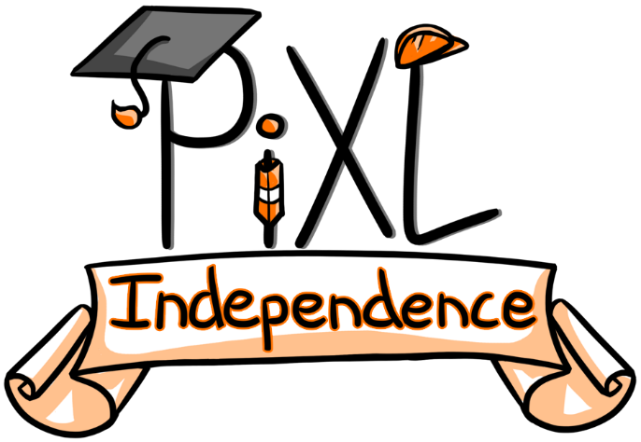

Commissioned by The PiXL Club Ltd.

This resource is strictly for the use of member schools for as long as they remain members of The PiXL Club. It may not be copied, sold, or transferred to a third party or used by the school after membership ceases. Until such time it may be freely used within the member school.

All opinions and contributions are those of the authors. The contents of this resource are not connected with, or endorsed by, any other company, organisation or institution.

PiXL Club Ltd endeavour to trace and contact copyright owners. If there are any inadvertent omissions or errors in the acknowledgements or usage, this is unintended and PiXL will remedy these on written notification.

